**Tutorial 8**

**Binary Tree**

1. Draw a Binary Tree stored integer number having root node = 30, there are 3 nodes on the left of the Tree and the height of this tree is 3

2. Give 2 example of Full Binary Tree

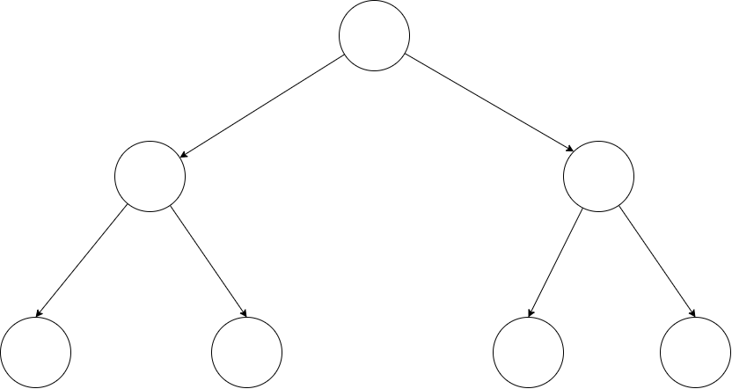

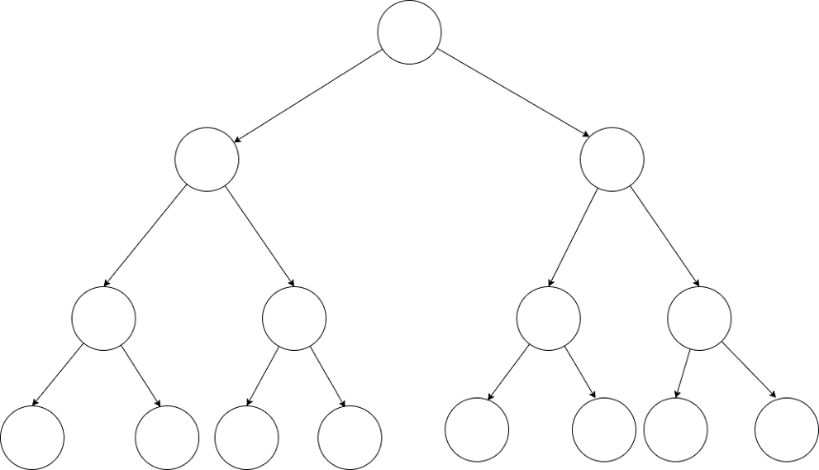

3. Give 2 example of complete binary tree which is not a full binary tree

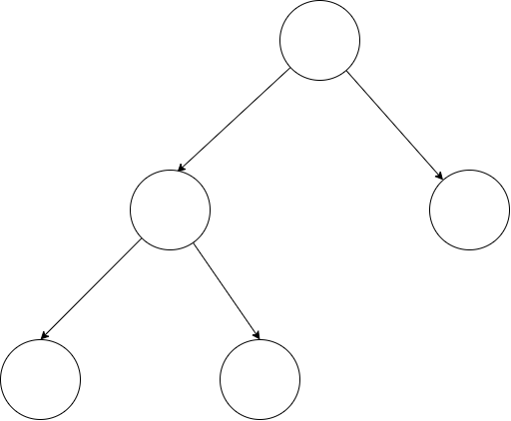

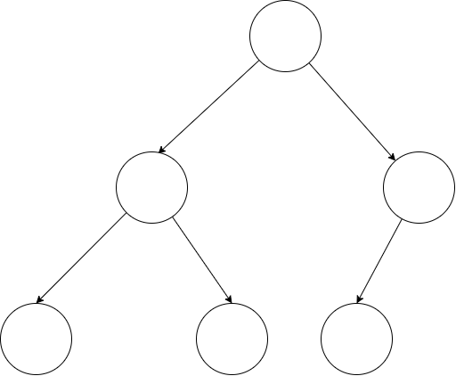

4. Binary Tree can be used to represented mathematical expression. We usually use “Infix” expression in everyday life i.e. a+b to say “a plus b”, but there are 2 more possible formats which are “prefix and postfix” i.e. “+ab and ab+” respectively. Use the inorder, preorder, and postorder traversals to determine the infix, prefix, and postfix expression from the following tree

4.1



Infix: 5 * ( (7-8)+(4/1))

4.2



Prefix: -*BX+/ZYE

4.3



Postfix: qau+-tw/z-m+/

5. From the following tree:

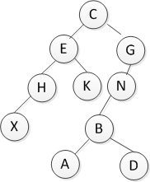

In order Traversal : XHEKCABDNG

Pre-order Traversal: CEHXKGNBAD

Post order Traversal: XHKEADBNGC

6. Infix to prefix expression conversion using stack

(2+**45**^6/(7+8))

6.1 Reverse the infix expression

))8+7(/6^**45**+2(

6.2 Make every ‘(‘ as ‘)’ and every ‘)’ as ‘(‘

((8+7)/6^**45**+2)

6.3 Convert expression to postfix form

|  |  |  |  |
| --- | --- | --- | --- |
| **Expression** | **Stack** | **Output** | **Comment** |
| ((8+7)/6^**45**+2) |  |  | Initial |
| (8+7)/6^**45**+2) | ( |  | Push |
| 8+7)/6^**45**+2) | (( |  | Push |
| +7)/6^**45**+2) | (( | 8 | Keep |
| 7)/6^**45**+2) | ((+ | 8 | Push |
| )/6^**45**+2) | ((+ | 87 | Keep |
| /6^**45**+2) | ( | 87+ | Pop stack until find ( |
| 6^**45**+2) | (/ | 87+ | Push |
| ^**45**+2) | (/ | 87+6 | Keep |
| **45**+2) | (/^ | 87+6 | Push |
| +2) | (/^ | 87+6**45** | Keep |
| +2) | ( | 87+6**45**^/ | + priority is smaller than ^ and / |
| 2) | (+ | 87+6**45**^/ | Push |
| ) | (+ | 87+6**45**^/2 | Keep |
|  |  | 87+6**45**^/2+ | Pop all and End |

**6.4 Reverse the expression and show the result**

**Postfix :** 87+6**45**^/2+

**Infix :** +2/^**45**6+78

Result = +2/^**45**6+78